**PROJECT DESIGN PHASE**

**-**

**1**

**PRO**

**BLEM**

**SOLUTION**

**FIT**

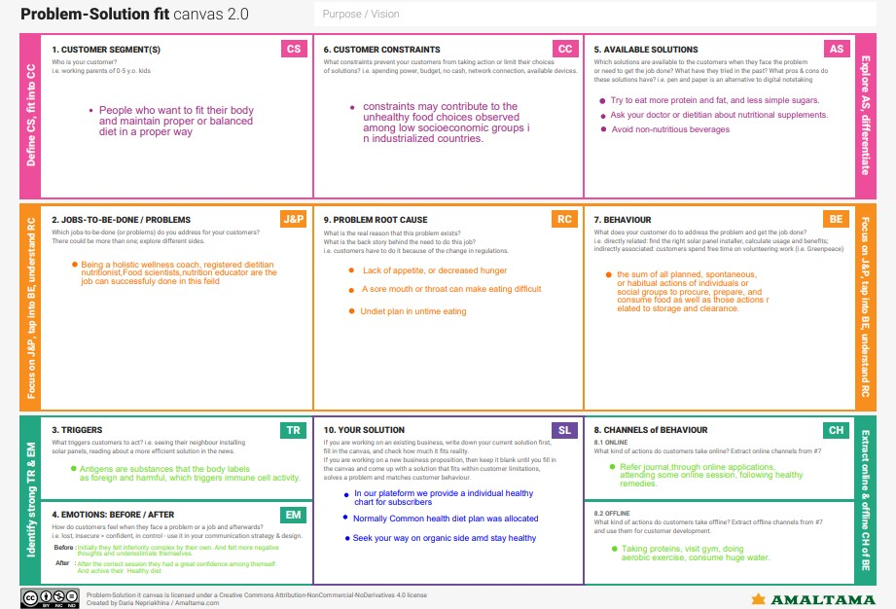

Date

1

16October

2022

Team ID

PNT2022TMID50493

Project Name

AI Powered Nutrition Analyst for

Fitness Enthusiasts.

Maximum Marks

2

Marks